הפקולטה למדעי הבריאות

טופס דו"ח התקדמות – תלמידי מחקר
(הסטודנט מתבקש לצרף תקציר דו"ח התקדמות)

אל : יו"ר ועדת תלמידי מחקר
מאת: (שם המנחה) פרופ' אלון מונסונגו

הנדון: דו"ח התקדמות של מר/גב' אנה דרנקו מס' זהות 320609241

מהמחלקה ל אימונולוגיה, מיקרוביולוגיה וגנטיקה

בהסתמך על תקציר דו"ח ההתקדמות המצורף בזה, אני מאשר /ת את הדו"ח בציון:
1. מעולה 2. טוב מאוד 3. טוב

ההתקדמות של התלמיד:
1. משביעת רצון והוא יוכל לסיים את עבודתו במועד
2. משביעת רצון אך בשל קשיים בלתי צפויים שהתעוררו צפוי איחור במועד סיום העבודה
3. איטית וצפוי איחור במועד סיום העבודה
4. בלתי משביעת רצון

במקרה שסומן סעיף 2 או 3 נא פרט, הסבר את הקשיים והערך את מידת האיחור. במקרה
שסומן סעיף 4 נא צרף המלצתך לגבי המשך הלימודים.

יציאתה של אנה לחופשת לידה וכן עיכובים טכנים הקשורים בתקופה. ייתכן ויהיה צורך בסמסטר נוסף

תאריך:_12-02-21__ חתימה:_________ ________
..................................................................................................................................

התייחסות ראש המחלקה:

1. מאשר/ת את חוות דעת המנחה
2. חולקת/ת על חוות דעת המנחה – פירוט:

______________________________________________________________

______________________________________________________________

תאריך:_____________ חתימה___________________

אישור יו"ר ועדת תלמידי מחקר

תאריך:_____________ חתימה____________________

הוראות לכתיבת דו"ח התקדמות:

נא לכתוב את הדו"ח על פי הסעיפים הרשומים מטה עד 3 עמודים

- נושא המחקר
- רקע מדעי קצר
- מטרת המחקר (היפותזה ומטרות ספציפיות, כחמישה משפטים)
- תוצאות אשר הושגו במחקר לפי המטרות שהוגדרו בסעיף 3. אם יש שינוי במטרות מהצעת המחקר, נא לפרט מדוע נעשה השינוי.
- מהם היעדים לסמסטר הבא (בשילוב עם סעיף 4)

Lymphocyte dysregulation impacts cell senescence with aging

Introduction
Inflammation is a part of body defense mechanisms while part of it is exposure to pro- and anti-inflammatory cytokines that facilitate or reduce inflammation, respectively. Whereas in acute inflammation there is a short-term exposure (days to weeks) to pro-inflammatory cytokines, in chronic inflammation there is a long-term exposure (month to years) to those cytokines^{1,2,3,4,5,6}.
Nowadays it is known that inflammation is part of the causes to cell senescence. Senescence is irreversible cell cycle arrest in which cell is still metabolic active modifying their extracellular environment, some of such activity is Senescence Associated Secretion Profile (SASP). It triggered by a diversity of factors and contributes to the normal organismal process but also it acts as a tumor suppression mechanism by limiting aberrant proliferation^{7,8}.
Senescent cells do not identify with specific markers, however, there are some semi-selective characteristics as p16^{INK4a}, p21, and senescence-associated -galactosidase activity (SA-β-gal)⁹.
Age-associated immune dysfunction known also as “immune senescence” is an increased sensitivity of the body to infection and decreasing ability in inflammation reduction, tightly connected to CD4⁺ T cells increasing dysfunction with aging. With age, the repertoire of lymphocytes changes, decrease in naive subset relative part, and increase of proliferated lymphocytes^{10,11}.
In the human population life span varies from 40 to 80 years on average, as aging is functional degradation of the organism due to damage accumulation causing by internal and exogenous factors which cause to cells undergo senescence as a defense mechanism. Senescent cells accumulate during lymphocyte reduced potential to clearance of senescent cells play a great role in most age-related disease^{12,13}.

Research objectives

Hypothesis
Lymphocytes’ dysregulation with aging causes decreased clearance in accumulated senescent cells which may contribute to the maintenance of senescence cells.

Specific aims
- Computationally characterize key cytokines involved with cellular senescence.
- Determine whether CD4 lymphocyte subsets orchestrate senescent cell clearance.

Results
- Analysis was made on a Tabula-Muris-Senis (TMS)¹⁴ single cell RNA sequencing (scRNAseq) dataset, which includes scRNAseq in 16 tissues at 3, 12, 18, 24 and 30 months of age C57BL6 mice, to identify key cytokines involved in senescence. First, age groups were regrouped into three age groups: 1-3 month – young group, 18-24 month - old group, 30 month – supercentenarians group; to increase the statistical power (Table 1). We identified that the total cells number per mouse does not differ significantly between the new age groups (Figure 1a), but the senescent cells fraction is significantly increased from young to old age group, and decrease from old to very old (correspond to human supercentenarians) age group (Figure 1b). Senescent cells have been defined as cells expressing the hallmark genes of senescent cells Cdkn1a (p21) and Cdkn2a (p16^{INK4a}). In addition, age groups exhibit a difference in gene expression, that diverse in several cytokines that could act as predictors of bad or good aging. Cytokines as IL-1β, IL-6, TNF-α and CCL5 distinguish between senescent cells in the age groups (Figure 2). Senescent cells at old group divide into two groups: one group of cells with similar expression level of the cytokines in young and supercentenarians group; second group of cells with lower expression of the cytokine in old than in young and very old mice, likelihood because there are mice that age good and another group of mice age bad.
Table 1: Age groups of C57BL6 mice analyzed for senescent cells
Old age group | Total mice per group | Total cells per group | New age group | Total mice per group | Total cells per group
1 month | 2 | 25980 | Young | 9 | 71582
3 months | 7 | 45602 | Young | 9 | 71582
18 months | 4 | 44645 | Old | 10 | 118133
21 months | 2 | 35828 | Old | 10 | 118133
24 months | 4 | 37660 | Old | 10 | 118133
30 months | 4 | 55674 | Supercentenarians | 4 | 55674

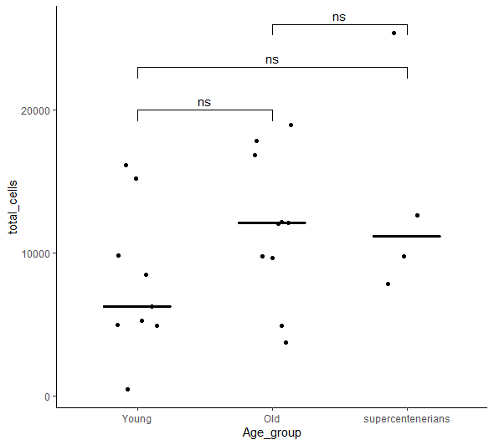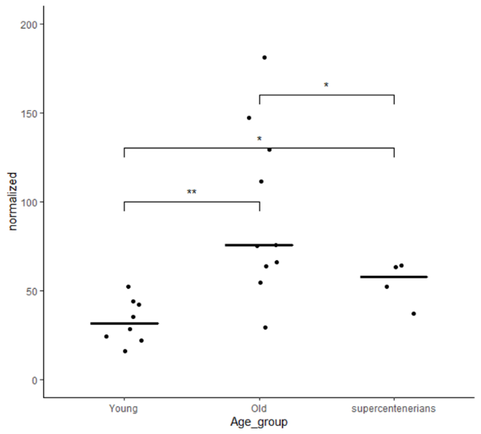
a
b
Figure 1:
- Distribution of total cells analyzed per mouse, shows nonsignificant change in the total cell number between age groups.
- Normalized distribution to 10000 cells of senescent cells per mouse per age group, shows significant increase of senescent cell fraction from young to old and very old groups, and significant decrease of senescent cells fraction from old to supercentenarians group. Also, the old group shows high variability with regard to the number of senescent cells in each mouse, which may indicate the pace of aging.
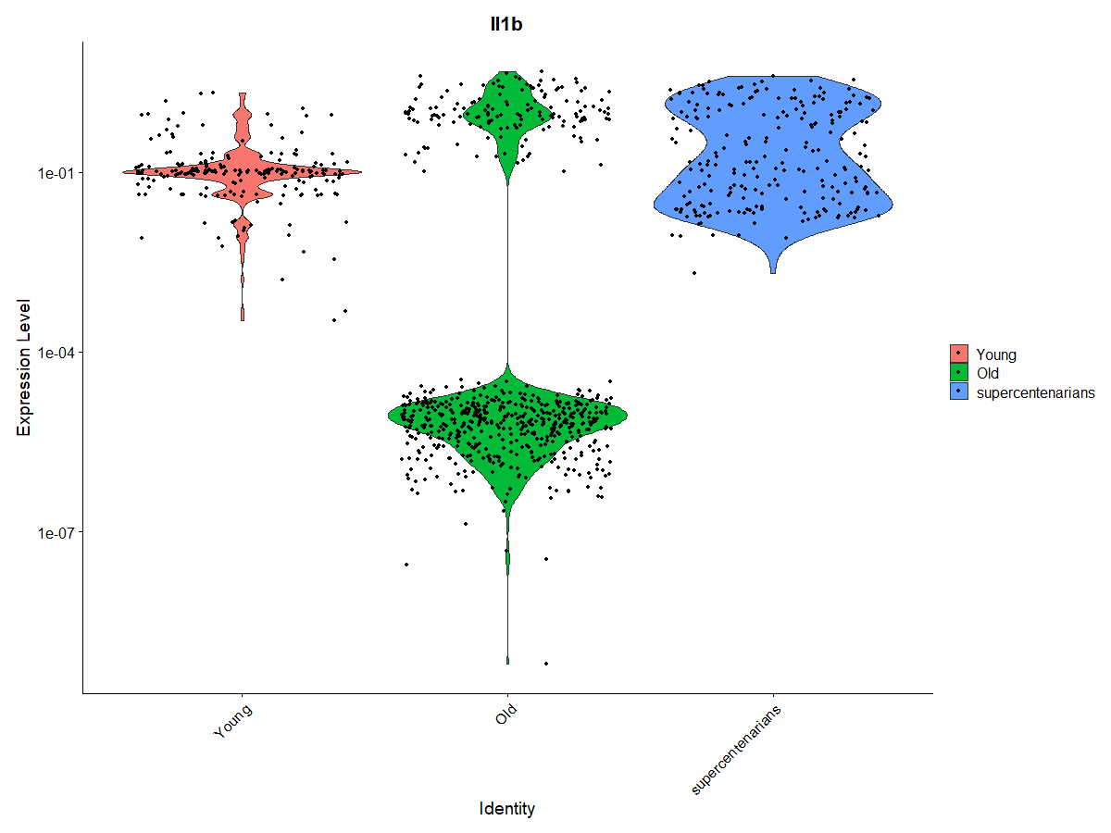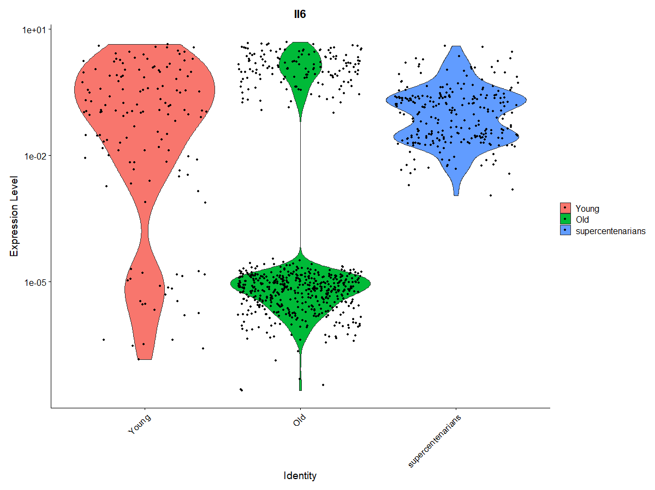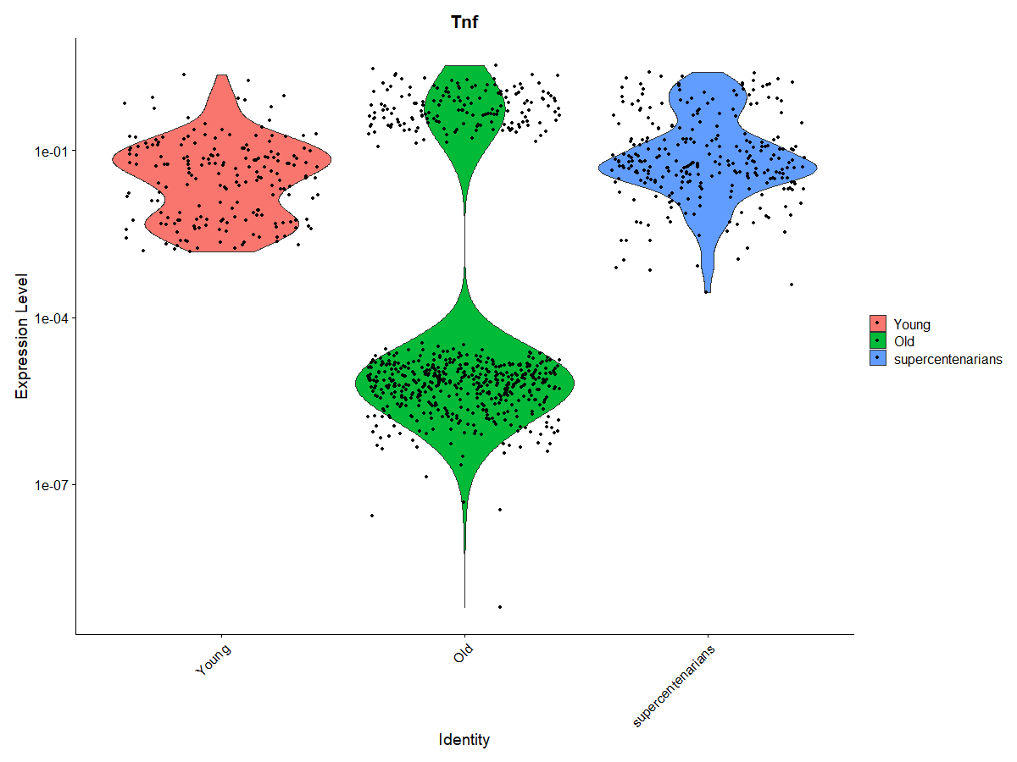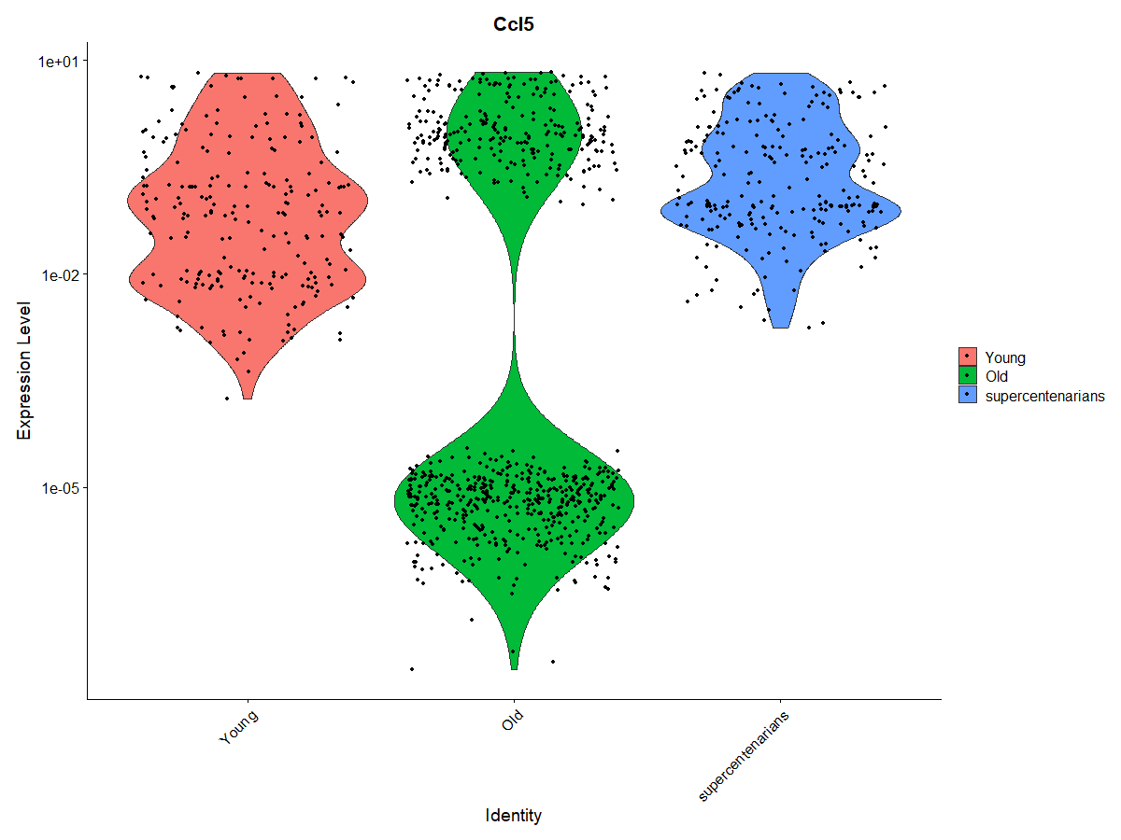
a
b
c
d
Figure 2:

Expression level of Il-1β (a), IL-6 (b), TNF (c) and CCL5 (d) in the identified senescent cells according to the age groups.

Future planes
- Merge of human single-cell RNA sequencing datasets from 3 studies investigated CD4⁺ cytotoxic T lymphocytes (CTLs) in different conditions: Supercentenarians¹⁵, Covid-19¹⁶ and Bladder Cancer¹⁷. Also, integration analysis of CD4⁺ CTL subset from human Supercentenarians dataset with CD4⁺ CTL subset from mouse aging dataset¹¹ to understand the regulation of CD4⁺ CTLs.
- Analysis of Tabula-Muris-Senis (TMS)¹⁴, clustering for T cells and Monocytes, also analysis of five tissues Spleen, Liver, Lung, Kidney and Marrow for T cells and Monocytes.
Combine results of TMS Spleen with Elyahu, Y et al.¹¹
- Staining of tissues for the senescent cell markers p21 and p16^{INK4a} and analyze correlations with the frequency of age-related T cells and systemic low-grade inflammation.

References
- Pahwa R, Goyal A, Bansal P, et al. Chronic Inflammation. [Updated 2020 Jul 4]. In: StatPearls [Internet]. Treasure Island (FL): StatPearls Publishing; 2020 Jan-. Available from: https://www.ncbi.nlm.nih.gov/books/NBK493173/
- Tanaka, T., Narazaki, M., & Kishimoto, T. (2014). IL-6 in inflammation, immunity, and disease. Cold Spring Harbor perspectives in biology, 6(10), a016295. https://doi.org/10.1101/cshperspect.a016295
- Parameswaran, N., & Patial, S. (2010). Tumor necrosis factor-α signaling in macrophages. Critical reviews in eukaryotic gene expression, 20(2), 87–103. https://doi.org/10.1615/critreveukargeneexpr.v20.i2.10
- Tau, G., & Rothman, P. (1999). Biologic functions of the IFN-gamma receptors. Allergy, 54(12), 1233–1251. https://doi.org/10.1034/j.1398-9995.1999.00099.x
- Dinarello C. A. (2018). Overview of the IL-1 family in innate inflammation and acquired immunity. Immunological reviews, 281(1), 8–27. https://doi.org/10.1111/imr.12621
- Carl, J. W., & Bai, X. F. (2008). IL27: its roles in the induction and inhibition of inflammation. International journal of clinical and experimental pathology, 1(2), 117–123.
- Childs, B. G., Durik, M., Baker, D. J., & van Deursen, J. M. (2015). Cellular senescence in aging and age-related disease: from mechanisms to therapy. Nature medicine, 21(12), 1424–1435. https://doi.org/10.1038/nm.4000
- HAYFLICK, L., & MOORHEAD, P. S. (1961). The serial cultivation of human diploid cell strains. Experimental cell research, 25, 585–621.
https://doi-org.ezproxy.bgu.ac.il/10.1016/0014-4827(61)90192-6
- Dodig, S., Čepelak, I., & Pavić, I. (2019). Hallmarks of senescence and aging. Biochemia medica, 29(3), 030501. https://doi-org.ezproxy.bgu.ac.il/10.11613/BM.2019.030501
- Ray, D., & Yung, R. (2018). Immune senescence, epigenetics and autoimmunity. Clinical immunology (Orlando, Fla.), 196, 59–63.
https://doi-org.ezproxy.bgu.ac.il/10.1016/j.clim.2018.04.002
- Elyahu, Y., Hekselman, I., Eizenberg-Magar, I., Berner, O., Strominger, I., Schiller, M., Mittal, K., Nemirovsky, A., Eremenko, E., Vital, A., Simonovsky, E., Chalifa-Caspi, V., Friedman, N., Yeger-Lotem, E., & Monsonego, A. (2019). Aging promotes reorganization of the CD4 T cell landscape toward extreme regulatory and effector phenotypes. Science advances, 5(8), eaaw8330. https://doi.org/10.1126/sciadv.aaw8330
- López-Otín, C., Blasco, M. A., Partridge, L., Serrano, M., & Kroemer, G. (2013). The hallmarks of aging. Cell, 153(6), 1194–1217.
https://doi-org.ezproxy.bgu.ac.il/10.1016/j.cell.2013.05.039
- Zhang, P., Kishimoto, Y., Grammatikakis, I., Gottimukkala, K., Cutler, R. G., Zhang, S., Abdelmohsen, K., Bohr, V. A., Misra Sen, J., Gorospe, M., & Mattson, M. P. (2019). Senolytic therapy alleviates Aβ-associated oligodendrocyte progenitor cell senescence and cognitive deficits in an Alzheimer's disease model. Nature neuroscience, 22(5), 719–728.
https://doi-org.ezproxy.bgu.ac.il/10.1038/s41593-019-0372-9
- Almanzar, N., Antony, J., Baghel, A.S. et al. A single-cell transcriptomic atlas characterizes ageing tissues in the mouse. Nature 583, 590–595 (2020). https://doi.org/10.1038/s41586-020-2496-1
- Hashimoto, K., Kouno, T., Ikawa, T., Hayatsu, N., Miyajima, Y., Yabukami, H., ... & Carninci, P. (2019). Single-cell transcriptomics reveals expansion of cytotoxic CD4 T cells in supercentenarians. Proceedings of the National Academy of Sciences, 116(48), 24242-24251.
https://www-pnas-org.ezproxy.bgu.ac.il/content/116/48/24242.short
- Meckiff, B. J., Ramírez-Suástegui, C., Fajardo, V., Chee, S. J., Kusnadi, A., Simon, H., Eschweiler, S., Grifoni, A., Pelosi, E., Weiskopf, D., Sette, A., Ay, F., Seumois, G., Ottensmeier, C. H., & Vijayanand, P. (2020). Imbalance of Regulatory and Cytotoxic SARS-CoV-2-Reactive CD4+ T Cells in COVID-19. Cell, 183(5), 1340–1353.e16.
https://doi-org.ezproxy.bgu.ac.il/10.1016/j.cell.2020.10.001
- Oh, D. Y., Kwek, S. S., Raju, S. S., Li, T., McCarthy, E., Chow, E., Aran, D., Ilano, A., Pai, C. S., Rancan, C., Allaire, K., Burra, A., Sun, Y., Spitzer, M. H., Mangul, S., Porten, S., Meng, M. V., Friedlander, T. W., Ye, C. J., & Fong, L. (2020). Intratumoral CD4⁺ T Cells Mediate Anti-tumor Cytotoxicity in Human Bladder Cancer. Cell, 181(7), 1612–1625.e13.
https://doi-org.ezproxy.bgu.ac.il/10.1016/j.cell.2020.05.017

